Next Year Purchasing: Approving a Requisition
____________________________________________________

Only Users with the authority to approve Next Year Requisitions can access this window. The system allows Users to Approve/Disapprove individual items on the Requisition as well as approve the entire Requisition or return it to the Originator for additional editing or deletion. If you are the first approver, then the Account Codes must be completed prior to approving the Requisition.

_____1. Retrieving the requisition: From Next Year > Maintenance > Approve Requisition, requisitions needing approval display one at a time. You may review and approve this way or retrieve a particular requisition by selecting the Directory button. Enter desired criteria in the top of the Directory box to find specific Requisitions, or leave all fields blank and click Search to see all Requisitions pending approval. Select the Requisition Number you wish to review.

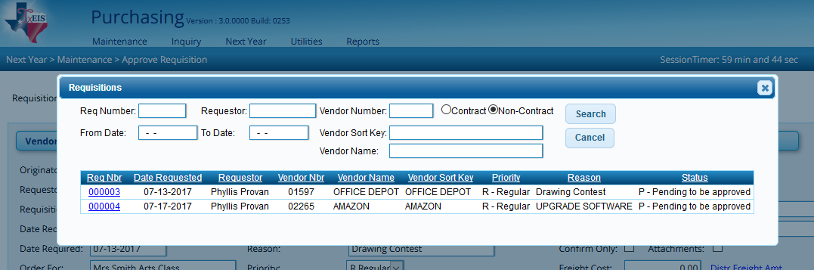

_____2. Reviewing the requisition: Review each item on the Requisition. Consider the following:

- Vendor Notes: a paperclip icon on this button indicates a message has been included for the vendor. This message will be printed on the PO for the vendor’s use. Click to review or edit.
- Comments: a paperclip icon on this button indicates a message has been included for your review. Comments are internal only and will not be printed on the PO. Click to review or use to enter additional or responsive comments. Note: We recommend using the Comments button to provide explanation any time you return a Requisition.

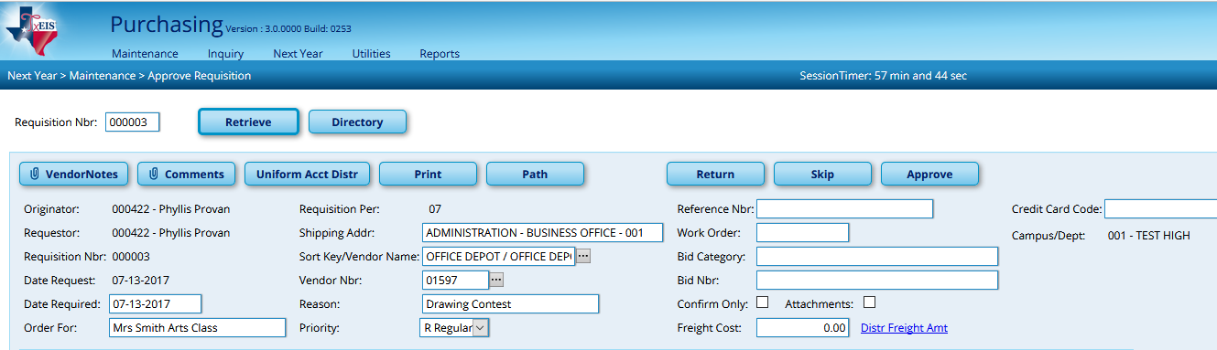

- Note: a paperclip icon on this button indicates a message has been included specific to this item. Notes are internal only and will not be printed on the PO.

- Coding: Account codes must be assigned by the originator or 1st approver. If you need to assign account codes, consider the following options (Option 2 is recommended):

  - Option 1: After each item is entered, add an account line in the bottom section. Select the Spyglass beside the Catalog number of each item in Section 2 (middle). In section 3 at the bottom, begin typing the account code desired, or click in the box and use the lookup button to search for a code. Select the desired account code. The Description will populate based on the account code selected.

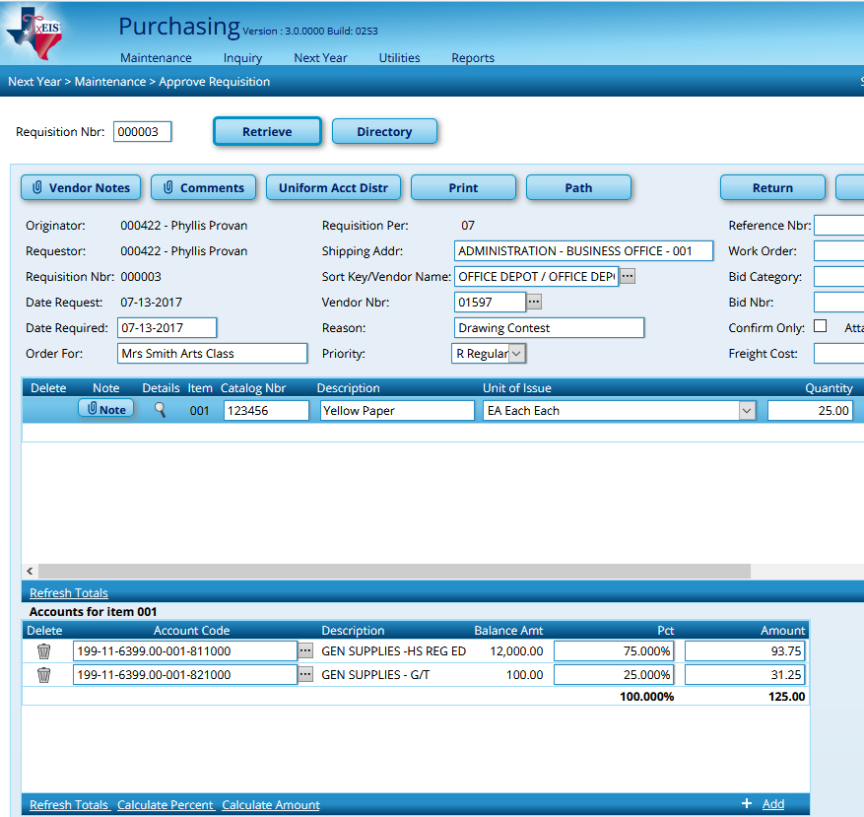

Note: Account Codes used in NYR requisition validate against Budget. Next Year Requisition and Purchase Orders can be created for amounts that exceed what has been approved in Budget. The system will post all requisitions and purchase orders, even if it results in exceeding the appropriated amount.

Once the account information has been entered, click on the Refresh Totals link to get totals in both percent and amount and to verify 100% of the line has been expensed.

Important Note: This option is line item driven, so the account information being entered will tie solely to the item whose Spyglass was selected in Section 2.

  - Option 2 (Recommended): Option 2 is much simpler as it will distribute costs uniformly across all items based on the percent or amount indicated. After entering all items and before you enter any account codes in the bottom section, select the Uniform Account Distribution button at the top of the screen.

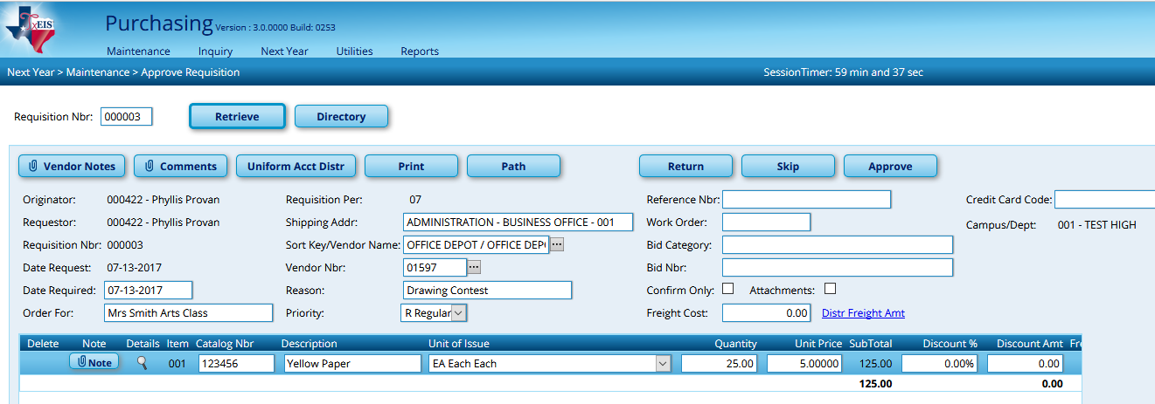

A pop-up box will display in which you will code the entire requisition. Select your account code. Just as in option #1, you will see the Budget balance for the account and you must assign the percent or amount of the entire requisition you want charged to that account. Add additional account codes as desired.

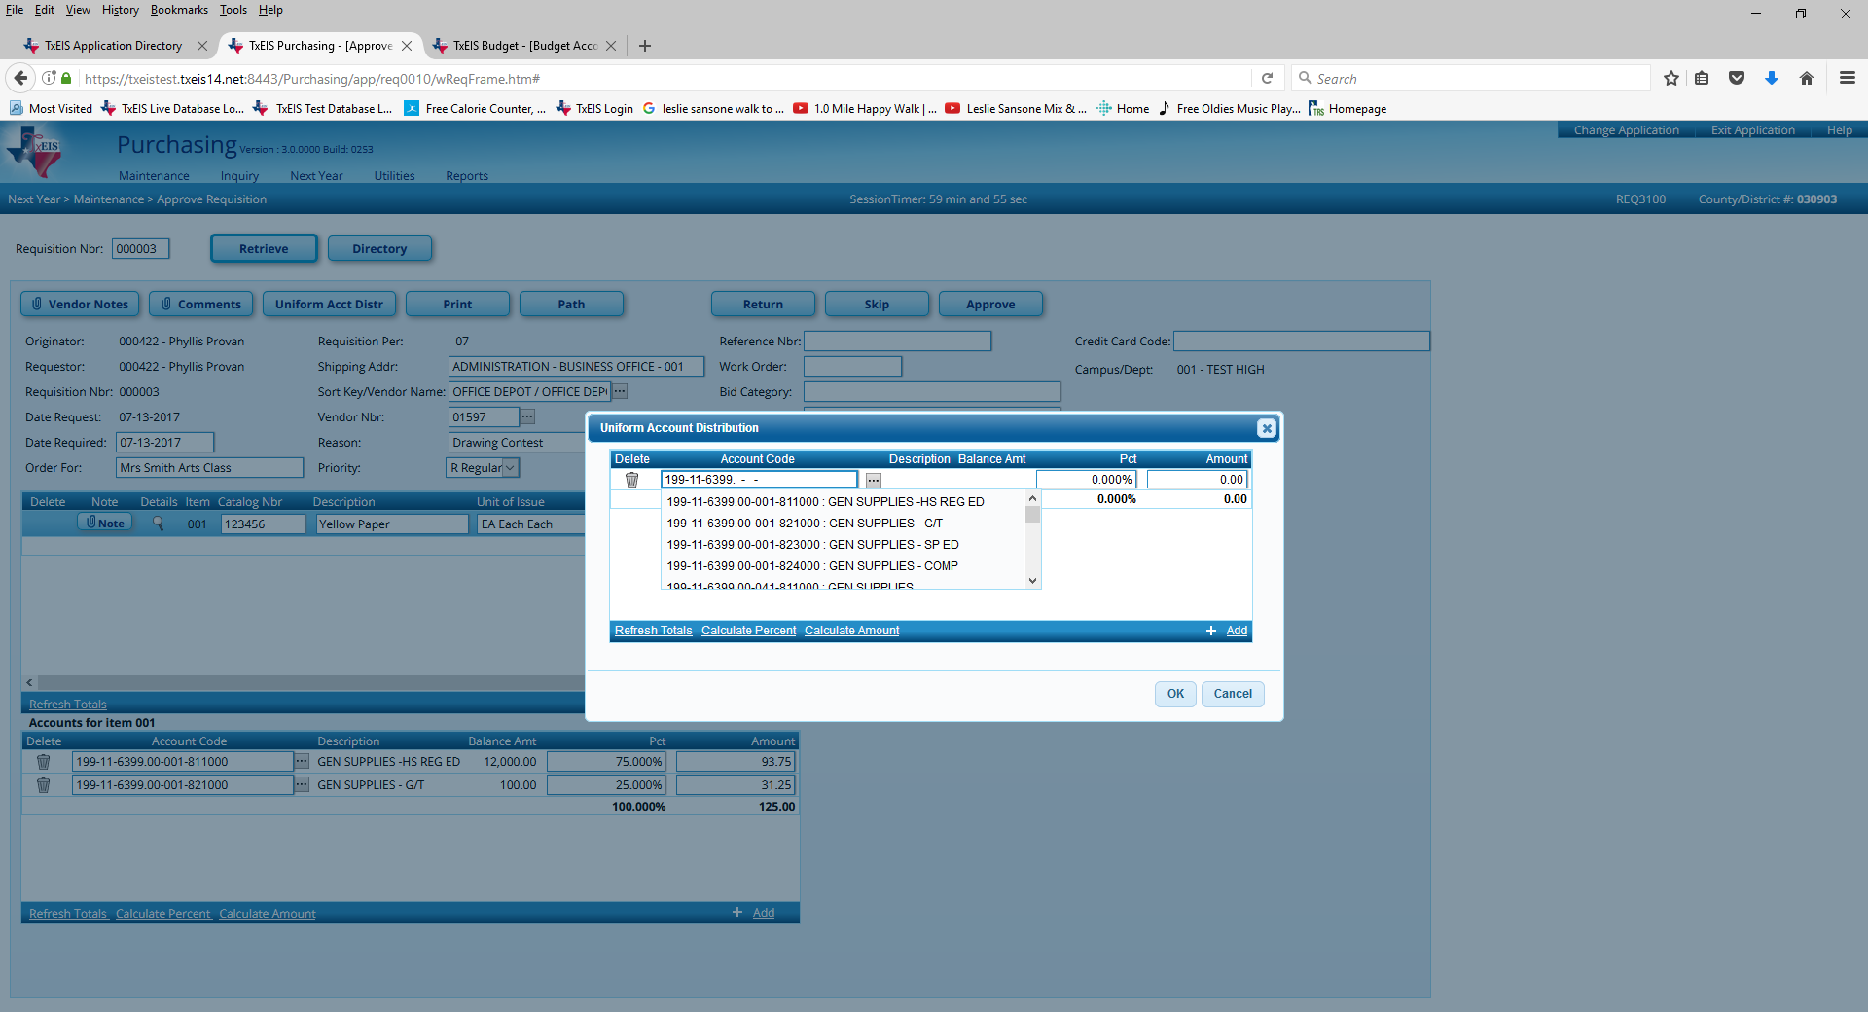

Once all accounts codes have been entered, select the Calculate Percent or Calculate Amount link. (If you entered by amount, calculate the percent; If by percent, calculate amount.) Your percent must equal 100% and the amount must equal the total for the requisition. Once it does, click OK.

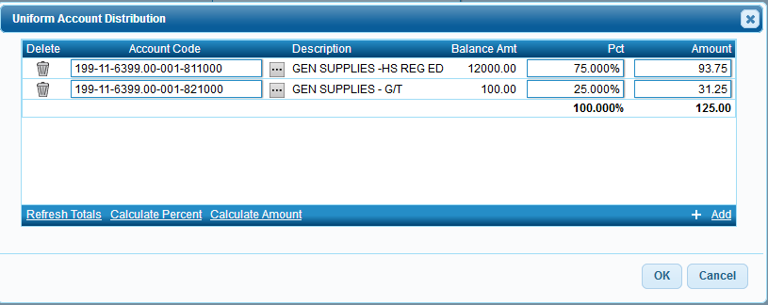

Important Note: The system will allow a requisition to be approved if the purchase will exceed the budget for that account code. If the items no longer will be ordered because of lack of money then RETURN the requisition. If arrangements are made with the Business Office to move budget amounts, then the approval process can continue.

_____3. Approving or Returning the requisition.

To Approve: Click the Approve button to send the requisition to the next approver. You will see a message saying “Submission for approval completed”. If you are the final approver, then the message will say a PO number has been assigned.

To Return: Select the Return button to disapprove the Requisition. This will return it to the Originator for editing or deleting. We recommend using the Comments button to tell the Originator why you are returning the Requisition. The Originator can then delete the requisition or make changes and re-submit for approval.

To Skip: Select Skip to skip the current Requisition and move to the next.

Path: Clicking this button displays the approval path and allows the Approver to Insert and/or Add an Approver in the path for this Requisition.

